Juvenile Court presentation examples and case studies

Situation:
I had been working with this reporter for weeks on bail reform and insisted he attend the first appearance calendar. He did but this is the story he wrote. I was furious about the first line saying that our judge made decisions with little to no regard of their ability to pay and ripped into him. He was incredibly apologetic and said it didn’t apply to King County judges, just Seattle. (That’s NOT what the story implied.) The next story he did about ITA Court (never published because he moved to Spokane), he called me to fact-check a zillion times and even let me read some of his story.
https://www.seattleweekly.com/news/locked-up-and-poor/
Situation
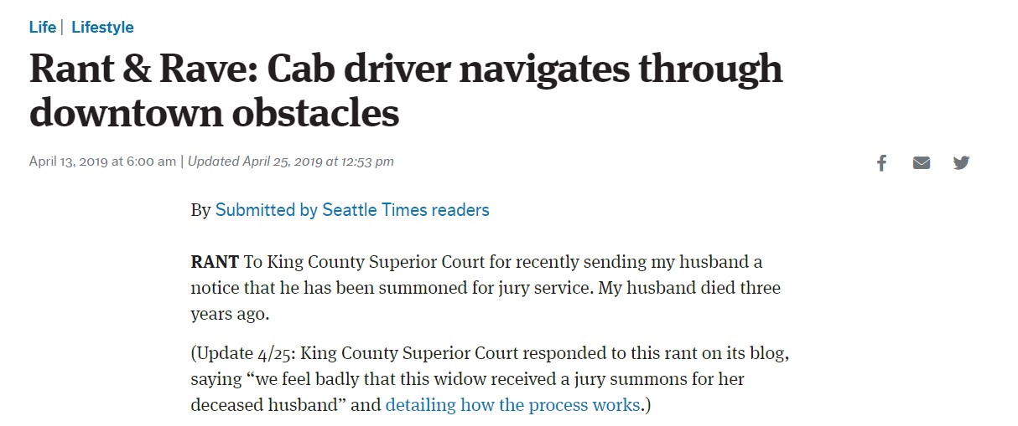
Here is the blog
https://kingcountysuperiorcourt.blog/2019/04/15/rant-rave-widow-receives-jury-summons-for-deceased-husband/
Situation:
Our alternative online news outlet (which has decent influence with the super left) wrote a story about Art at our Children and Family Justice Center…. And she didn’t contact us. I reached out to her – in a gentle, non-confrontational way – and got a great response and an opportunity to change the conversation.

Here is the email exchange:
Hi Agueda,
I saw your story about the art at the new Children and Family Justice Center. I was hoping that next time you might contact us in addition to others when you are putting together a story about this facility. We may not always want to comment but we would certainly like the option of doing so.
Thanks,
Jamie

From: Pacheco Flores, Agueda <Agueda.PachecoFlores@crosscut.com>
Sent: Friday, April 5, 2019 1:42 PM
To: Holter, Jamie <Jamie.Holter@kingcounty.gov>
Subject: Re: Stories involving the court

Thank you Jamie, I thought about that at the time, but was on deadline. I will most certainly reach out. Is there something I missed in the story that would have been said that could be a follow-up?

From: Holter, Jamie [mailto:Jamie.Holter@kingcounty.gov]
Sent: Friday, April 5, 2019 1:48 PM
To: Pacheco Flores, Agueda <Agueda.PachecoFlores@crosscut.com>
Subject: RE: Stories involving the court
Thanks – I am always available by phone and have most judges on speed dial. As you can imagine our Juvenile bench has very strong feelings about some things. I’m not sure what they would say at this very moment. But given the opportunity, they might want to provide their point of view if for no other reason than to provide context for the art issue.
From Agueda:
I do apologize. If the opportunity arises I will make sure to be more thoughtful and slow down.
Best,
Agueda
We did a follow up story where she was able to talk to the kids directly about art in the new facility.

Situation
My boss in the Tech Department said we weren’t getting enough credit with council about all the benefits we provided as an enterprise organization and he challenged me to produce something that would get noticed.
Strategy
I asked our own staff and then various department directors about the coolest products the IT org created for them. Our wastewater treatment division said IT pitched using Microsoft Hololens technology.
Task
Show and tell! I asked to go with them as they did training on this new technology and shoot a little video story on my ipad – yes, I shot the entire story on my ipad.
Result
https://www.youtube.com/watch?v=hPh6dosae9Y
I edited this with basic editing software that any kid can use. I sent it to Microsoft and Taqtile (our partners), sent it to the director of Wastewater and asked her to share it. Which she did. It got 1500 views and was picked up by a Wastewater trade magazine. Which was read by a Canadian Company. Which had employees fly to Seattle to review this product and our innovative use of it. Which led to a recommendation and an innovation award. Which really really really impressed council. and I got a 4.5 out of 5 on my annual review.
Then after I left, they leveraged that attention into a fully produced story for Geekwire
https://vimeo.com/280373316
https://kcemployees.com/2018/12/20/king-county-wins-award-for-using-microsoft-hololens-to-train-staff-at-west-point-wastewater-treatment-plant/
What does this mean for you?
It means asking questions and looking for stories is a great way to communicate about your work. There are so many free and low-cost tools to help tell stories in a way that is meaningful to your audience.
Media tools
News deserts are real things. A huge swath of our country doesn’t have a reliable “news organization” that publishes five credible news stories a week… which means we have to find other ways to tell our story besides local traditional media. It may be social media, other peoples’ blogs, our own blogs, or podcasts.

Social media
Social media varies by community. Find out where your community gets/posts information and connect there. It can be an online-only news org. Here’s one of ours that’s almost as important as the Seattle Times https://westseattleblog.com/
You need a place to shout your story – twitter, FB work. Post links to your stories. You can always email your blogs/press releases to these online news outlets.
Blogs
Blogs are easy to do and provide a great source of ground truth. They stay there forever and you can send links to them anytime you want anyone to know anything.
Best practices include: they can be long as long as they are interesting, pictures every 150 words if possible. Wordpress and squarespace make blog-hosting easy and cheap. Squarespace is only 17/month.
https://kingcountyparks.org/author/kingcountyparks/ this is beautiful and done with wordpress
https://kingcountyattendance.org/ this is useful and done with squarespace. It’s an entire website – created in about an hour. Should you contract out for this? No. Too expensive. There has to be someone on your team who can do it or has a son or daughter who can set you up.
Press releases
“Press releases” must contain who, what, where, when, why and a newshook (why are you telling me this today instead of tomorrow) You can send them to anyone who receives them – local media or local community blogs. Never more than 4 paragraphs. Always includes links to information/data/pictures if possible.
Podcasts
We have one and it has been really well received. https://kingcocourt.podbean.com/
I am also including my start-up guide “So you want to do a podcast”
Twitter
Twitter is a social media tool that all news organizations follow and it helps government agencies get information out quickly. Example? We gained 600 followers during our mini-snowstorm. I used twitter because our website was too slow and our news media/lawyers etc were too busy to check our website. You can have a personality on twitter, but it takes work. Twitter as an information venue is a better use of your time and resources.

